**1.**What exactly is []?

**Ans:** A empty list in python is represented by [] which don’t have any value.

**2.** In a list of values stored in a variable called spam, how would you assign the value 'hello' as the third value? (Assume [2, 4, 6, 8, 10] are in spam.)

**Ans:**

spam**=**[2,4,6,8,10]

print(spam)

spam[2]**=**'hello' *#List uses zero based indexing*

print(spam)

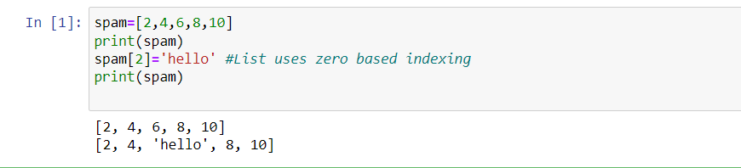

Let's pretend the spam includes the list ['a', 'b', 'c', 'd'] for the next three queries.

**3.** What is the value of spam[int(int('3' * 2) / 11)]?

**Ans:** spam[int(33/11)]= spam[3]=d #d will print.

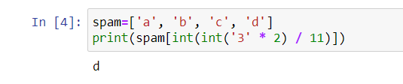

**4.** What is the value of spam[-1]?

**Ans:** spam[-1] will print the last element of spam list.

spam**=**['a','b','c','d']

print(spam[-1]) #’d’ will print.

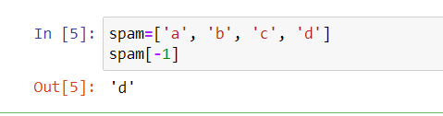

**5.** What is the value of spam[:2]?

**Ans:** spam[:2] returns all elements in the list spam from 0 to 2 excluding 2 as the ending value is 2.

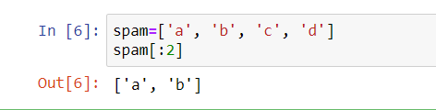

Let's pretend bacon has the list [3.14, 'cat,' 11, 'cat,' True] for the next three questions.

**6.** What is the value of bacon.index('cat')?

**Ans:** The value of bacon.index('cat') is 1 because indexing takes 1st occurrence.

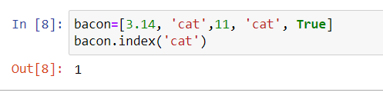

**7.** How does bacon.append(99) change the look of the list value in bacon?

**Ans:** append() method to add element at the end of the list value. For ex:

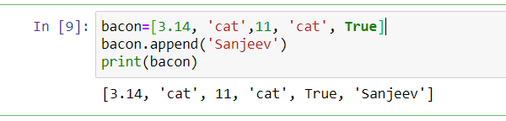

**8.** How does bacon.remove('cat') change the look of the list in bacon?

**Ans:** The remove method removes the first occurence of the element in the list.

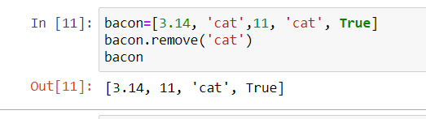

**9**. What are the list concatenation and list replication operators?

**Ans:**  The operator for list concatenation is +, while the operator for replication is *. (This is the same as for strings.)

**10**. What is difference between the list methods append() and insert()?

**Ans:** append() method only add the items at the end of the list whereas insert() adds anywhere in the given list.

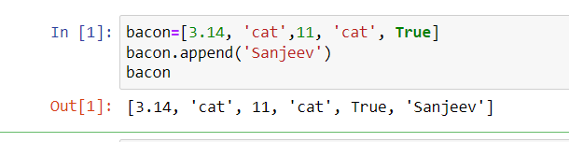

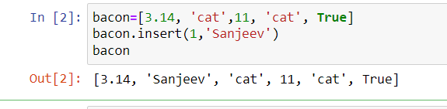

**11.** What are the two methods for removing items from a list?

**Ans:** remove() and del are used to remove items from a list.

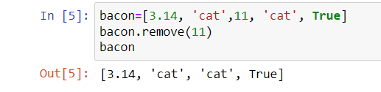

**12.** Describe how list values and string values are identical.

**Ans:** Both lists and strings can be passed to len() function, have indexes and slices, be used in for loops, be concatenated or replicated, and be used with the in and not in operators.

**13.** What's the difference between tuples and lists?

**Ans:** Tuple uses parenthsis () whereas lists use brackets [] to represent the items.

Tuple are immutable whereas lists are mutuable.

**14.** How do you type a tuple value that only contains the integer 42?

**Ans:** (42,) (The trailing comma is mandatory. otherwise its considered as a int by python Interpreter)

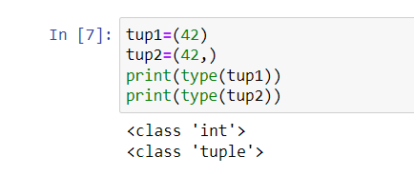

**15.** How do you get a list value's tuple form? How do you get a tuple value's list form?

**Ans:** The tuple() and list() functions, respectively are used to convert a list to tuple and vice versa.

**16.** Variables that "contain" list values are not necessarily lists themselves. Instead, what do they contain?

**Ans**: They contain references to list values.

**17.** How do you distinguish between copy.copy() and copy.deepcopy()?

**Ans:** The copy.copy() function will do a shallow copy of a list, while the copy.deepcopy() function will do a deep copy of a list. That is, only copy.deepcopy() will duplicate any lists inside the list.